RDCA Annual Golf Classic

The Annual RDCA Golf Classic was held this year on June 22nd at the Alberta Springs Golf Resort in Red Deer. A beautiful day for golf, the event was sold out with over 150 golfers participating. A huge thank you goes out to all the volunteers, participants and sponsors for making the event another great success. Congratulations to all winners of the contests and raffles. There was over $5,600 raised in donations, silent auction items and prizes that will be used to award our local apprentices with annual scholarships We look forward to seeing you all again next year!

1st Place – Alberta Parking Lot Services\
2nd Place – Group 2 Architecture and Interior Design Ltd.
3rd Place – Magnum Mechanical Ltd.
Past President’s Honesty Award – Legacy Roofing Ltd.

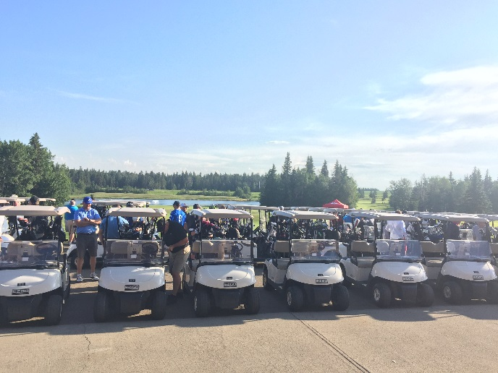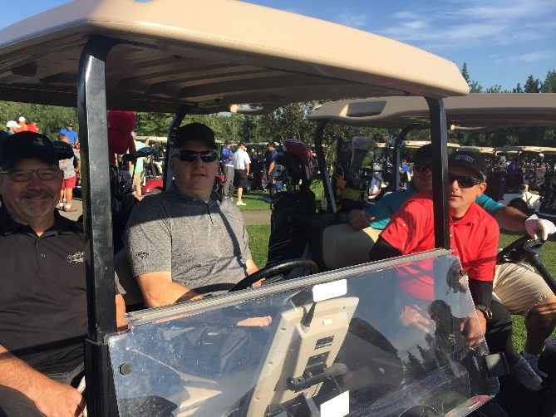

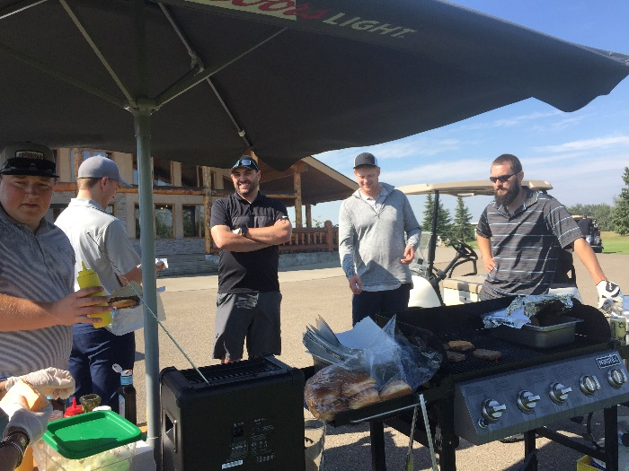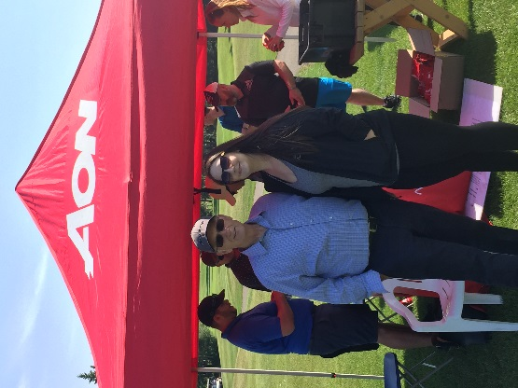

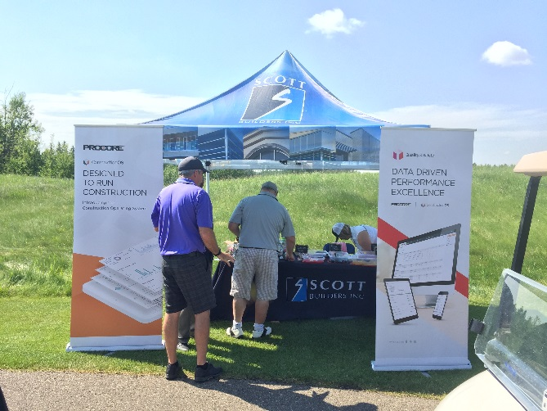

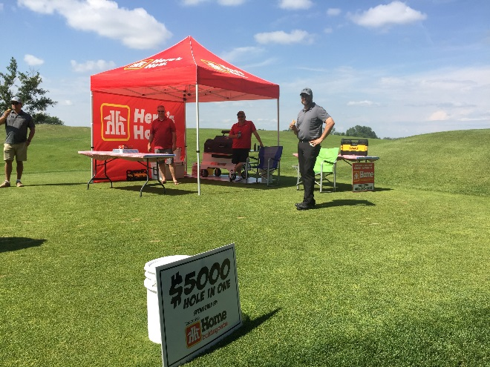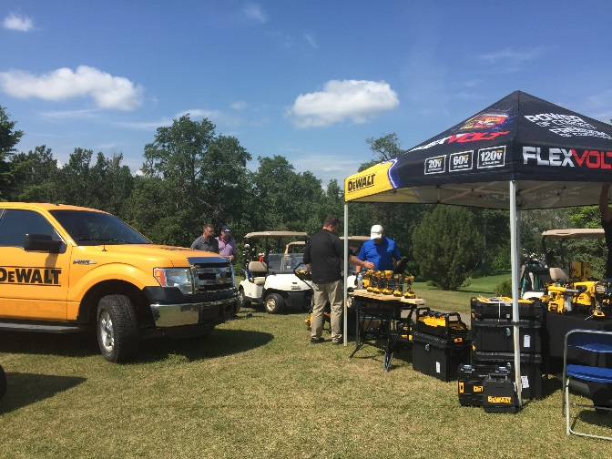

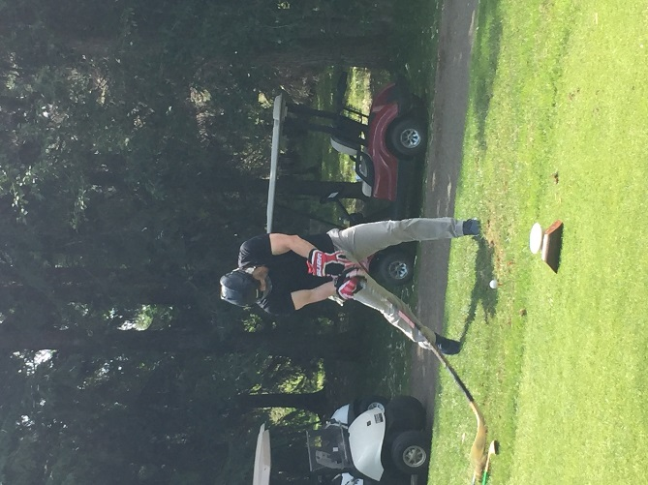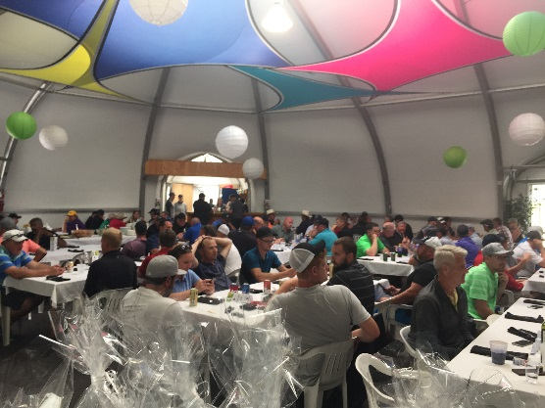

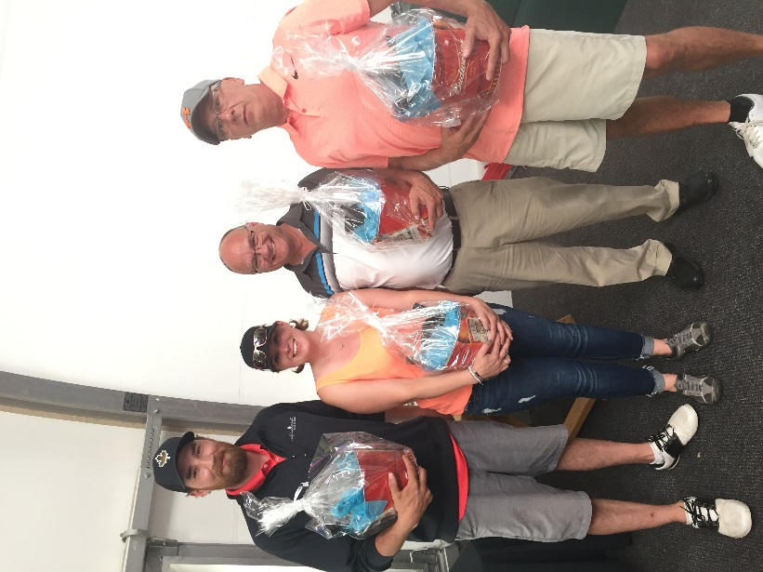
Alberta Parking Lot Services

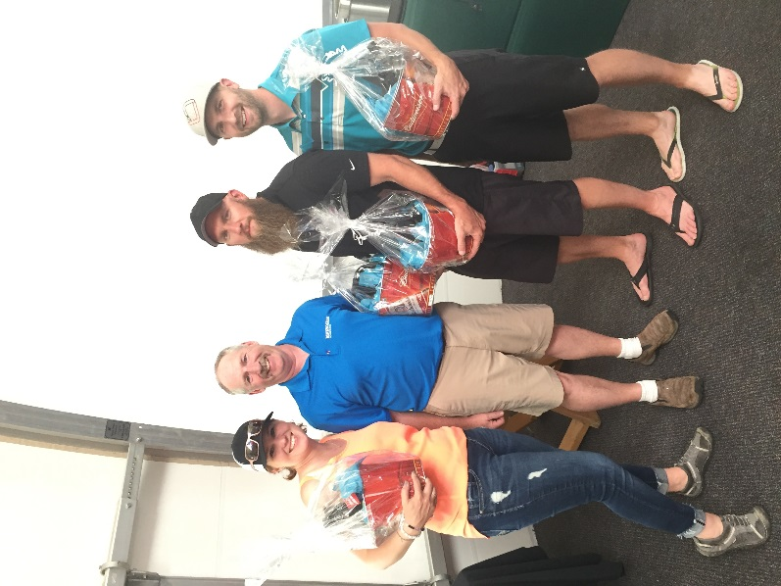

Group 2 Architecture

